**Verzeo**

**Microsoft Azure Cloud Computing**

**Major Project**

*Name: Aarish Ahmed Siddique*

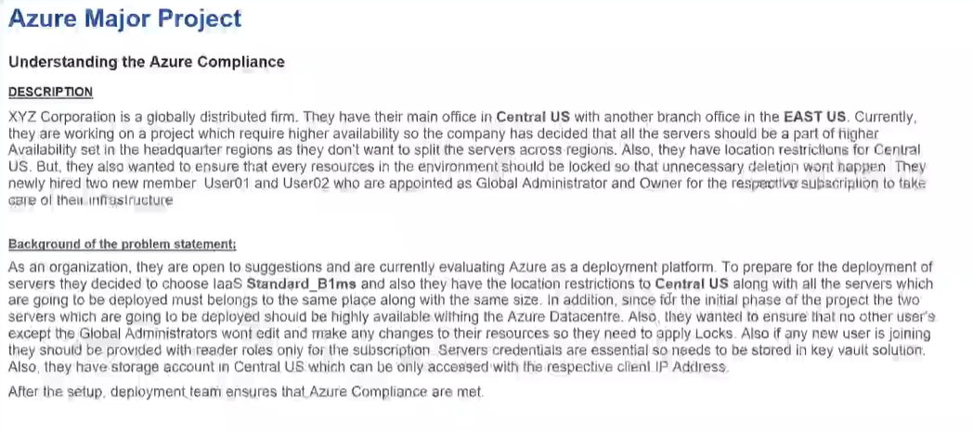

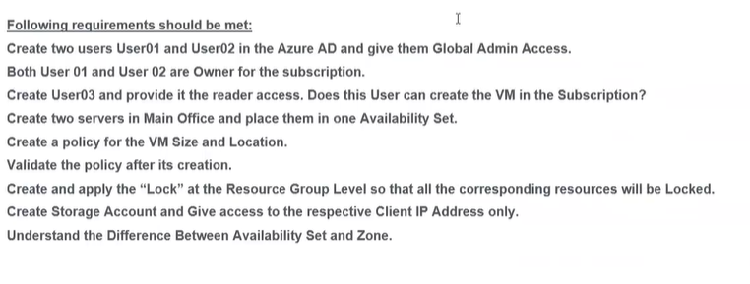

1. **Created User01 and gave Global Admin Access .**

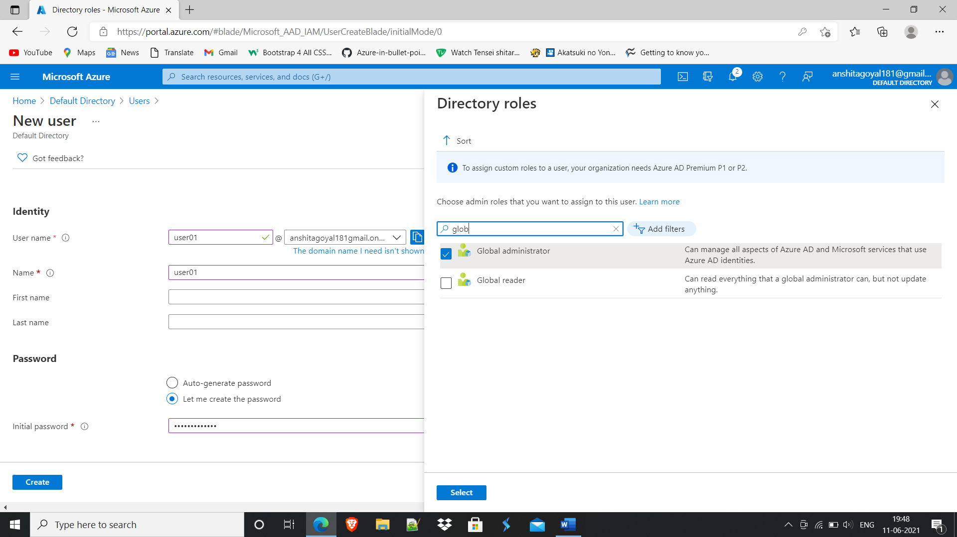

1. **Created User02 and gave Global Admin Access.**

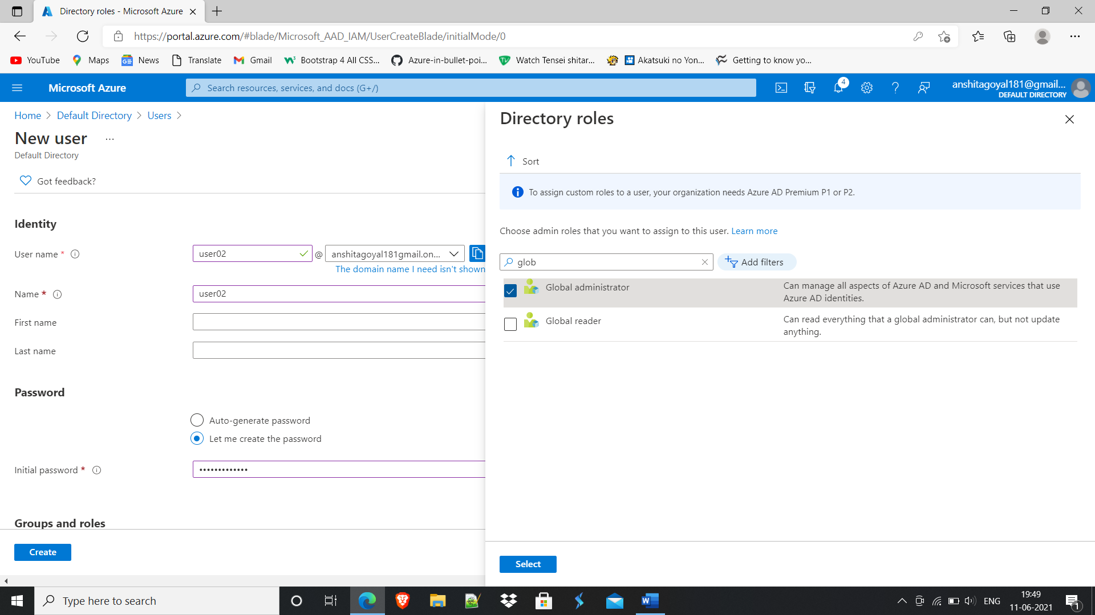

1. **Made User01 and User02 Owner of the Subscription.**

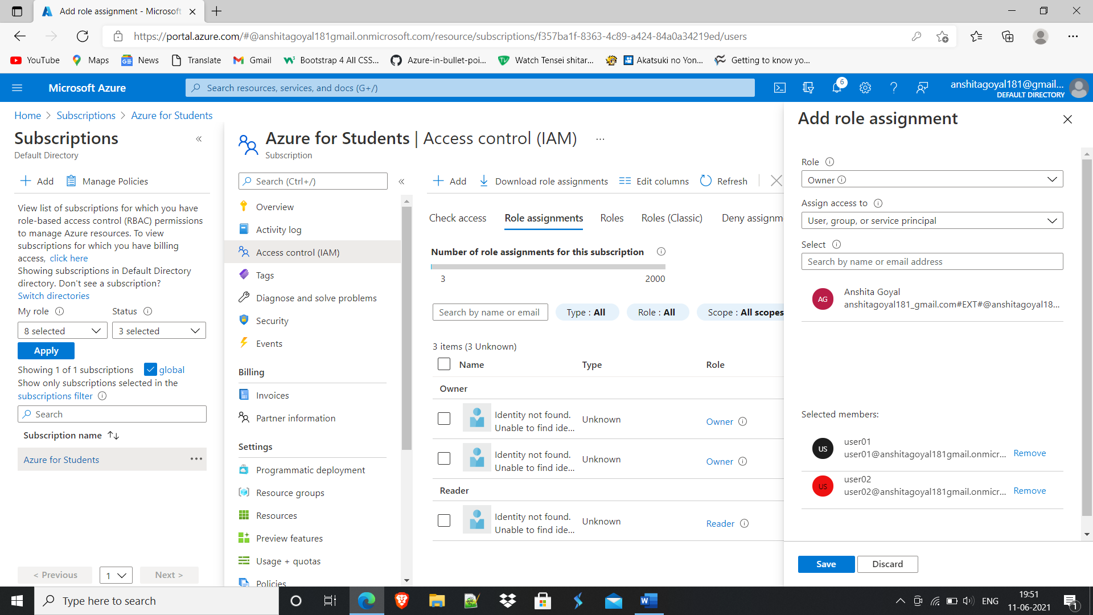

1. **Made User03 and gave it Reader Access.**

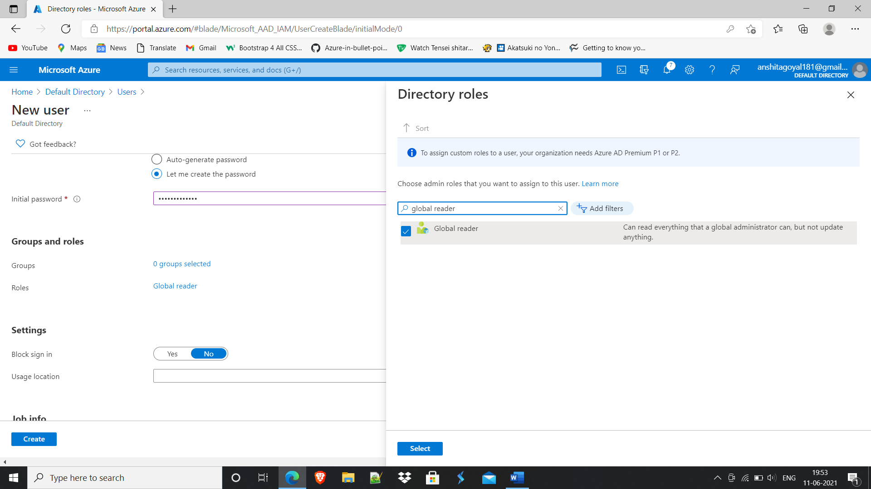

**Log in with User03.**

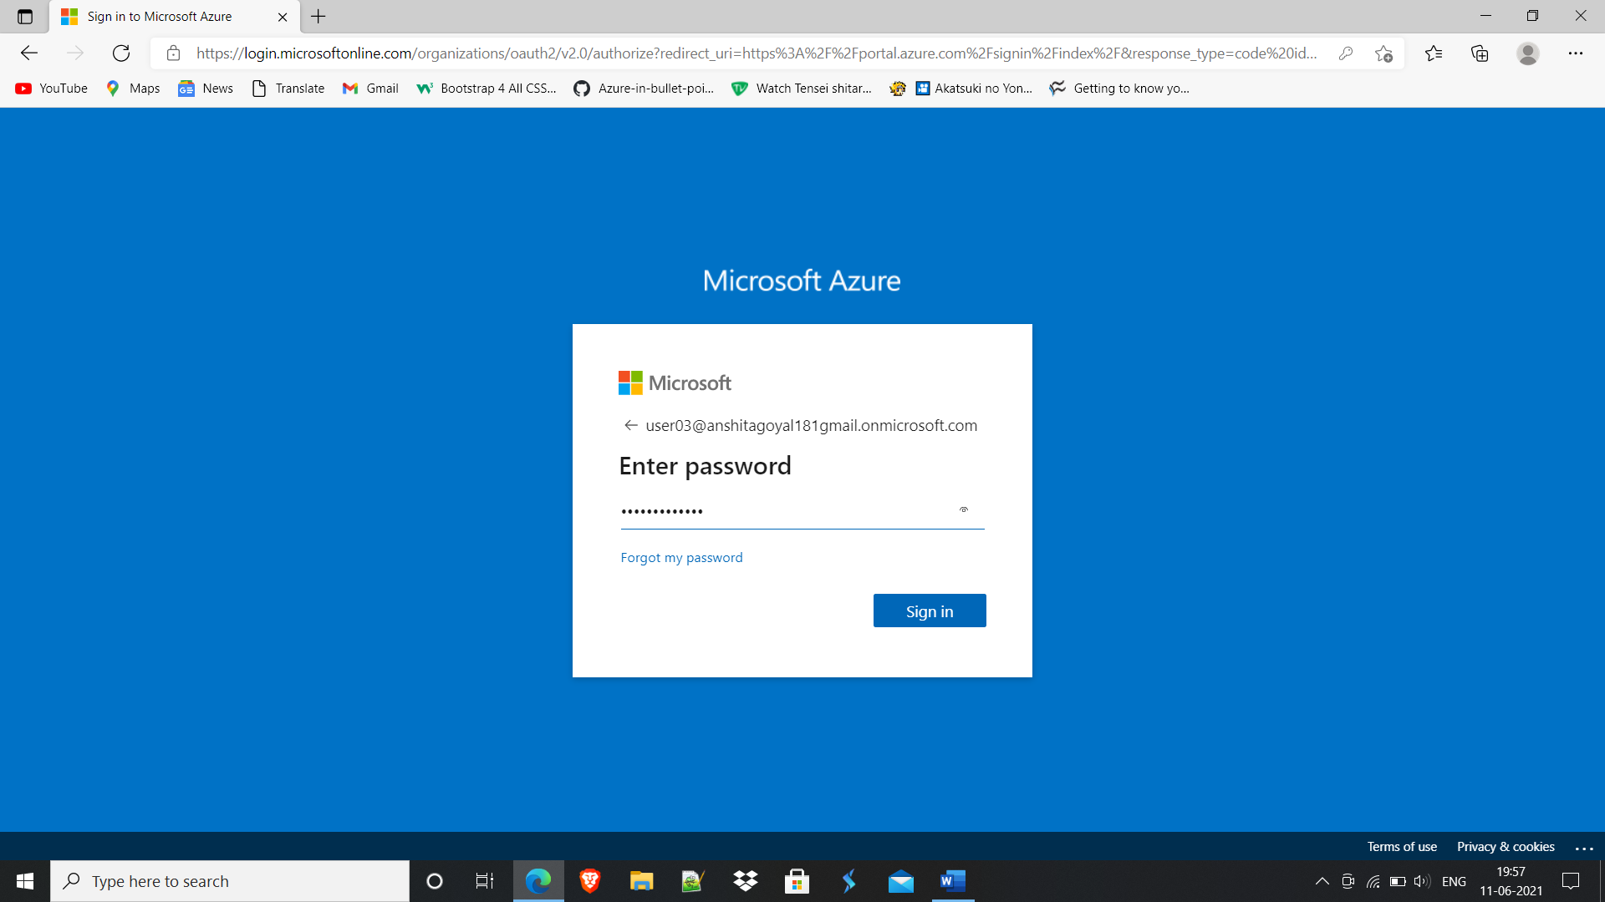

**User03 can’t create VM in this subscription because of Reader access.**

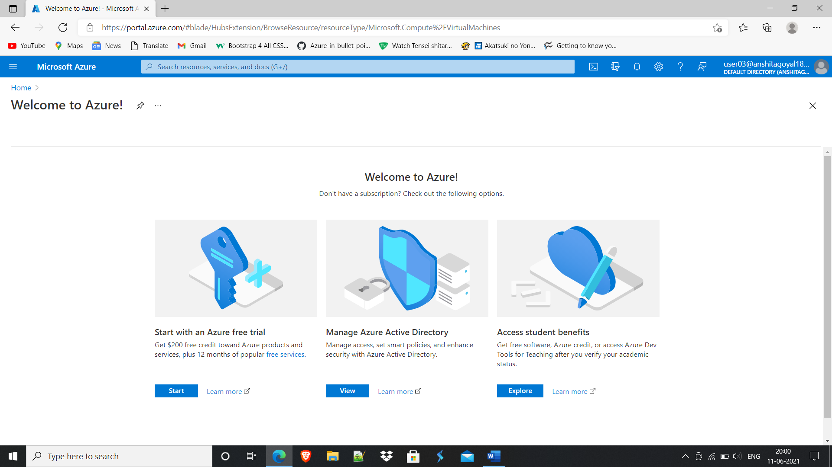

1. **Now login with User01**

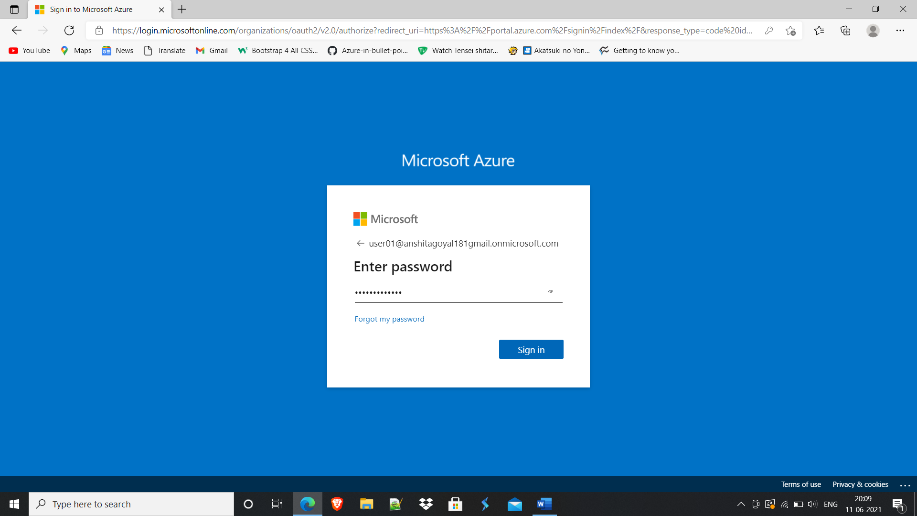

1. **Created Policy for VM size as Standard_B1ms.**

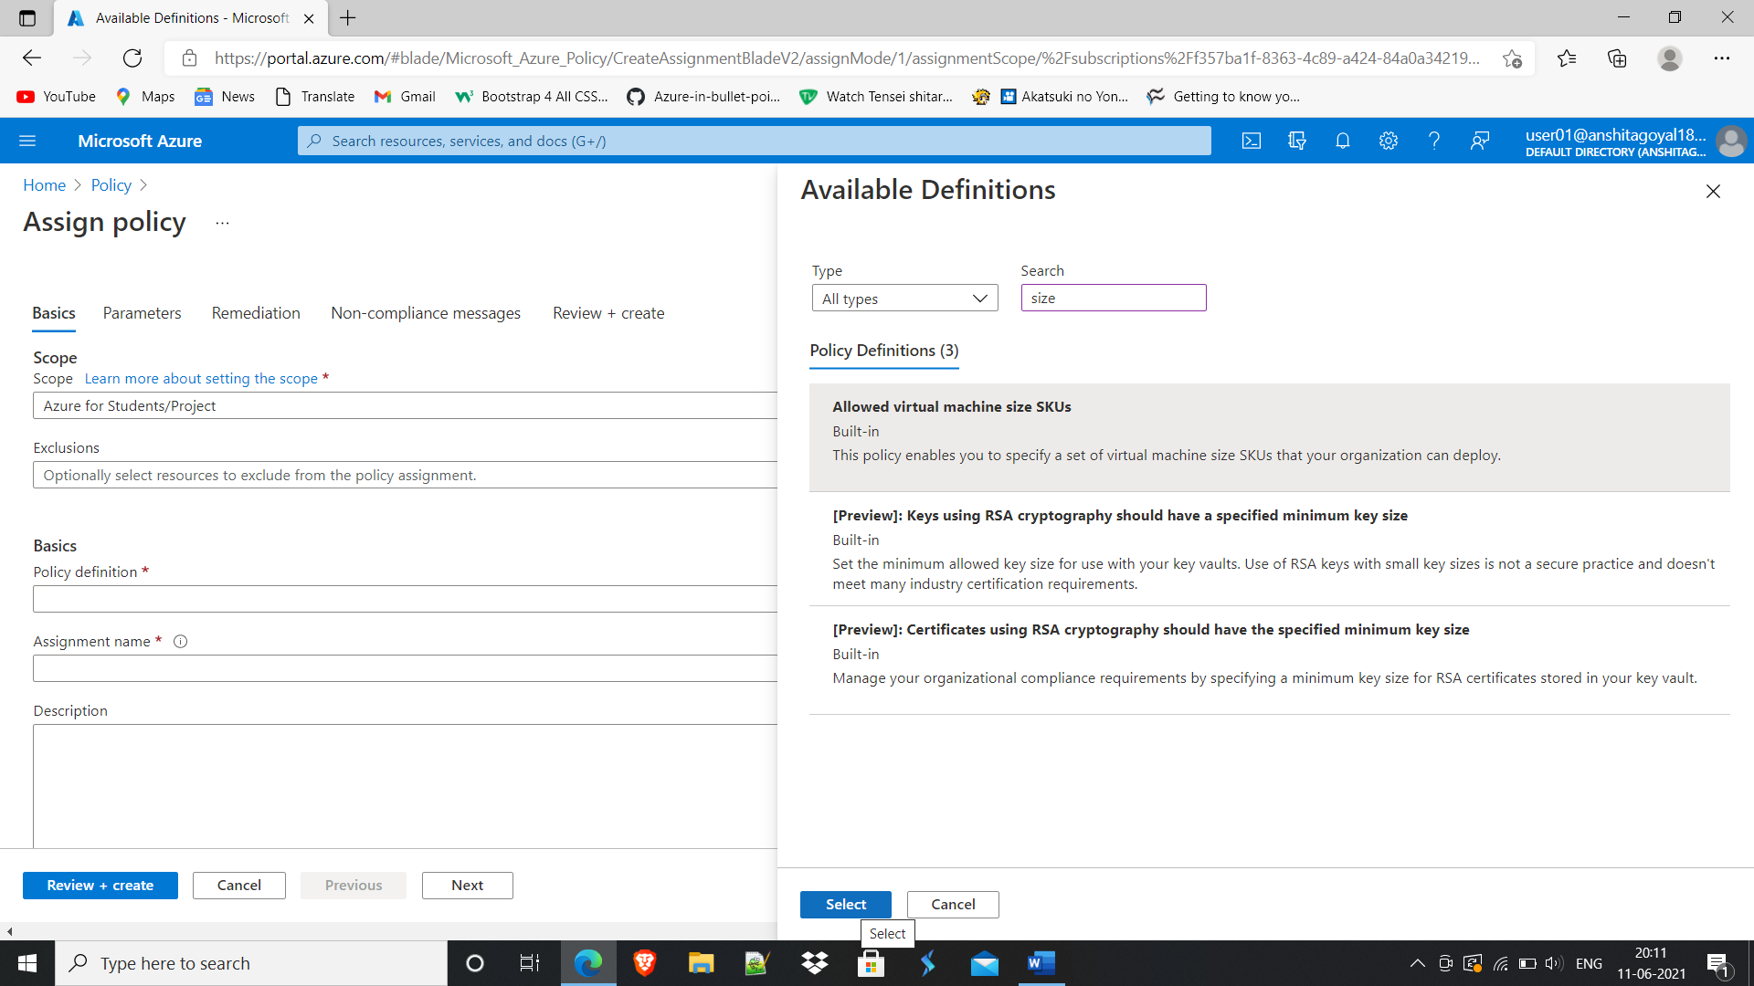

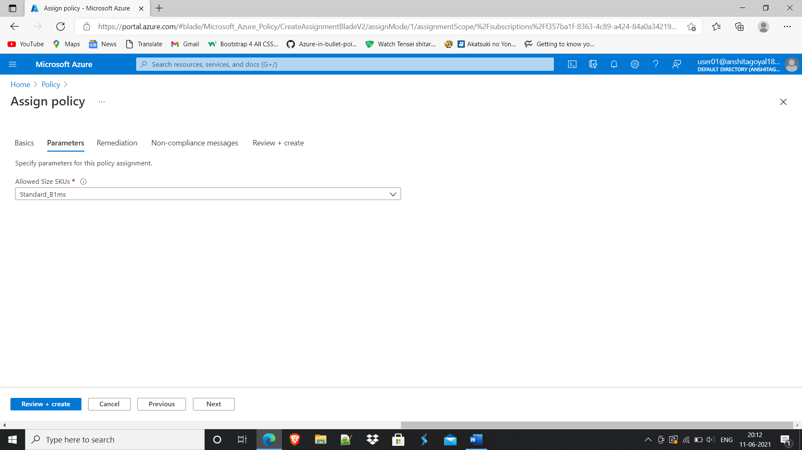

1. **Created Policy for VM location as Central US.**

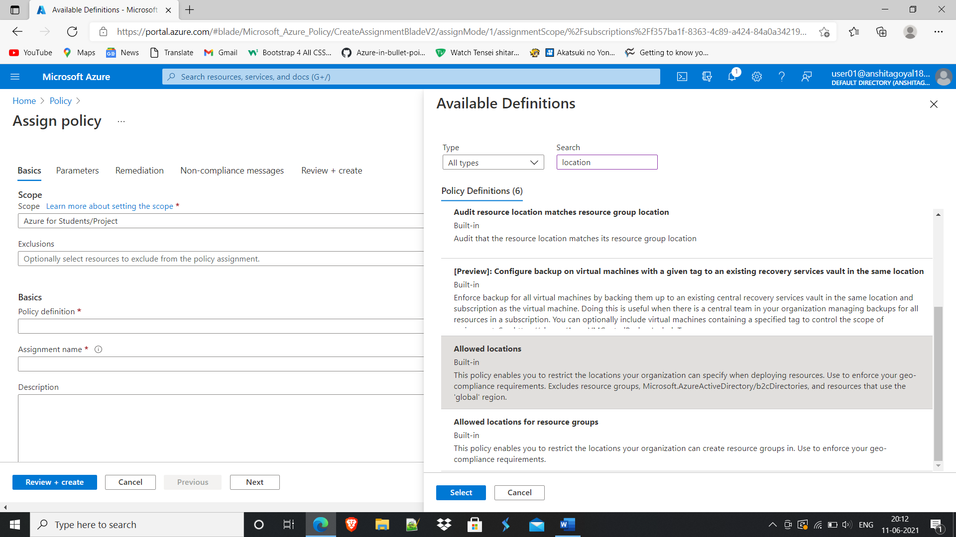

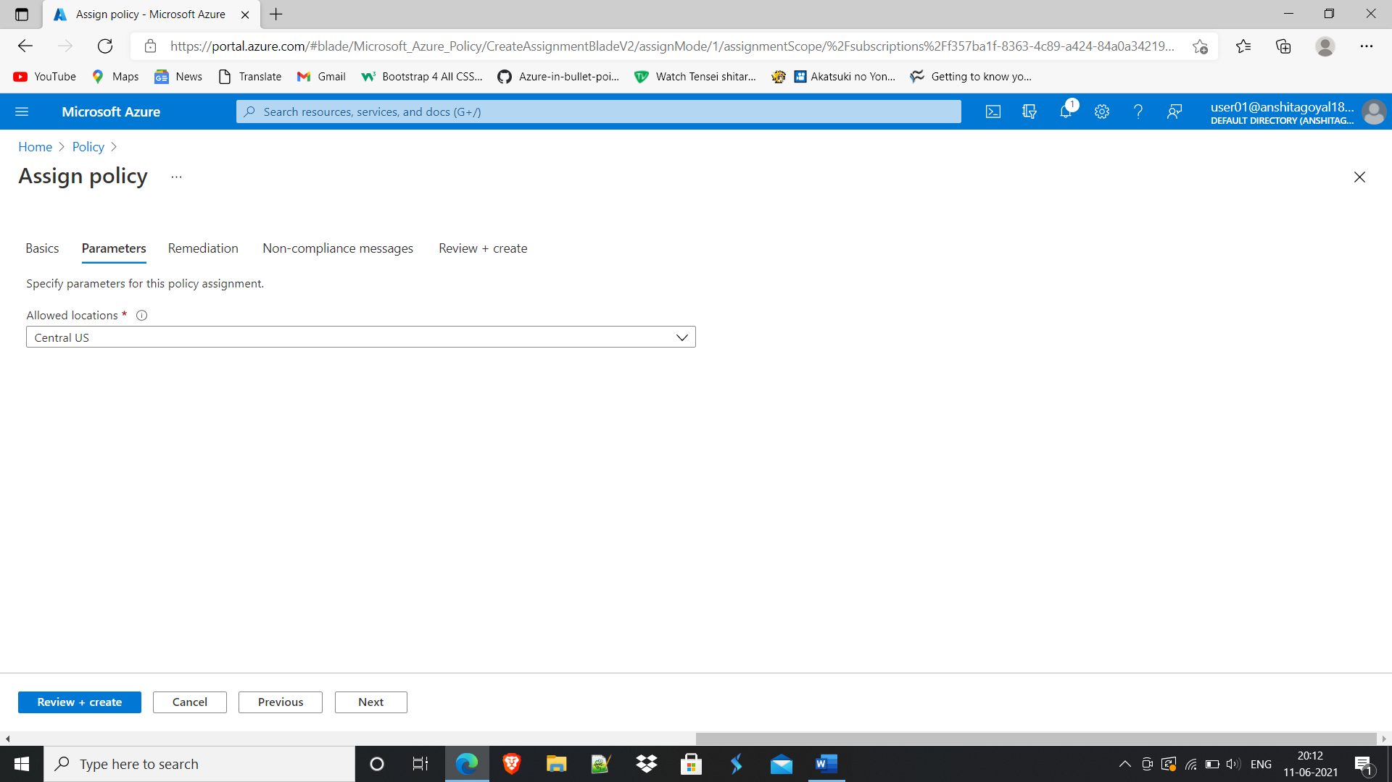

**A** new **policy** or initiative assignment **takes** about 30 minutes to be applied. New or updated resources within scope of an existing assignment become available in about 15 minutes. **A** standard compliance scan occurs every 24 hours.

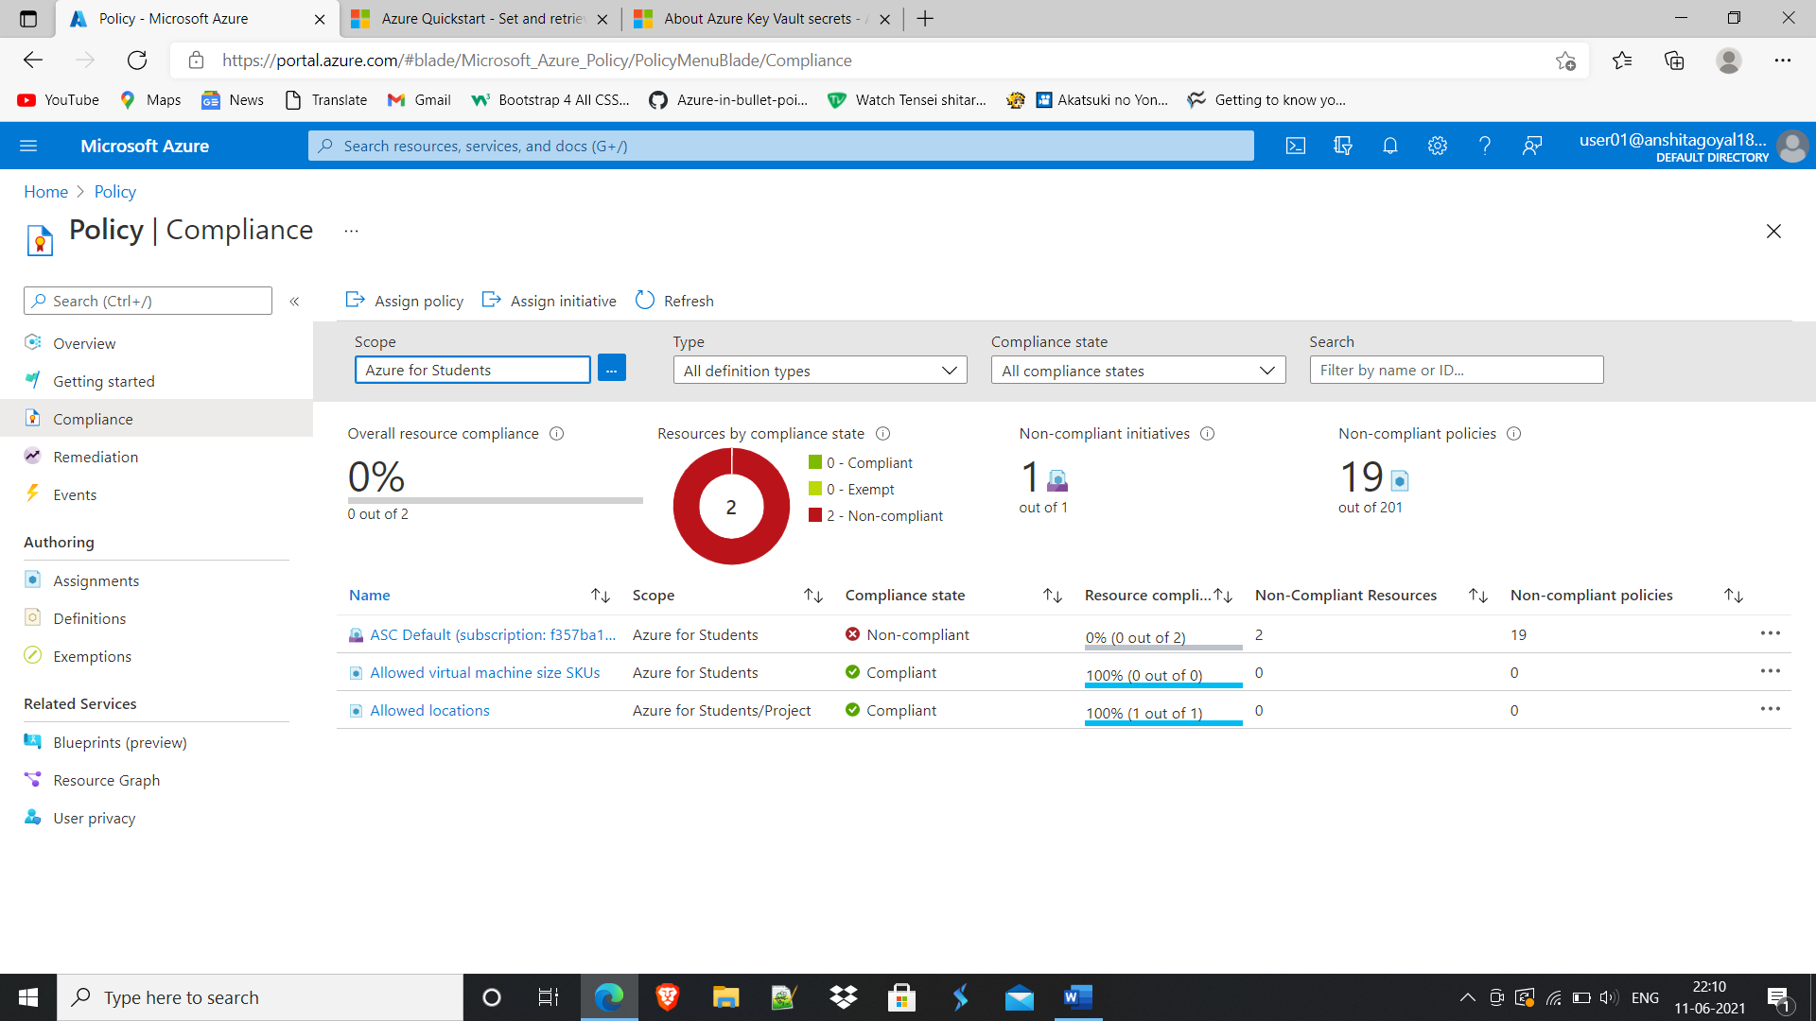

**To validate,**

**Tried to create VM in West US with size Standard_D2s_v3,**

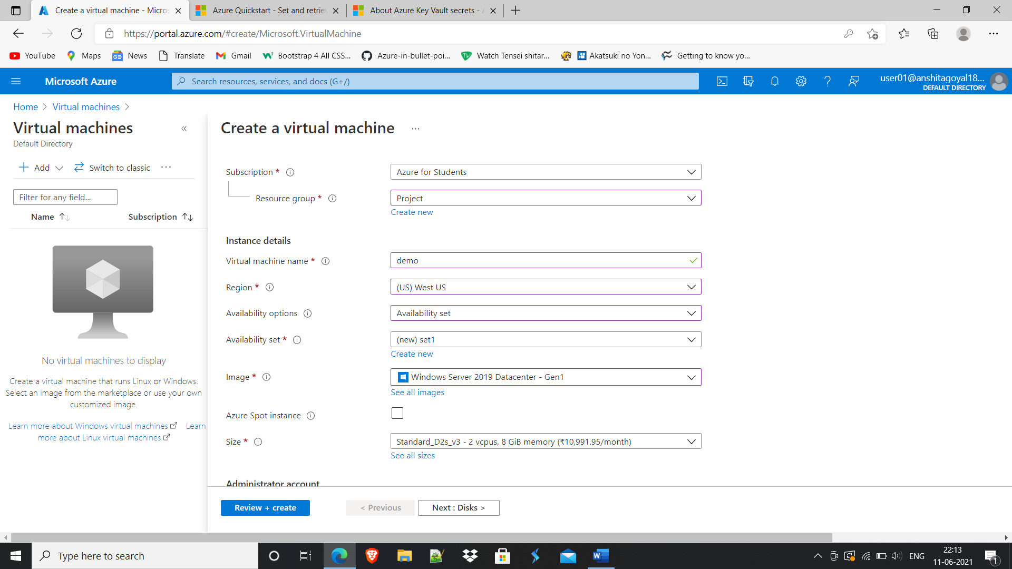

**Throwed a policy violation error.**

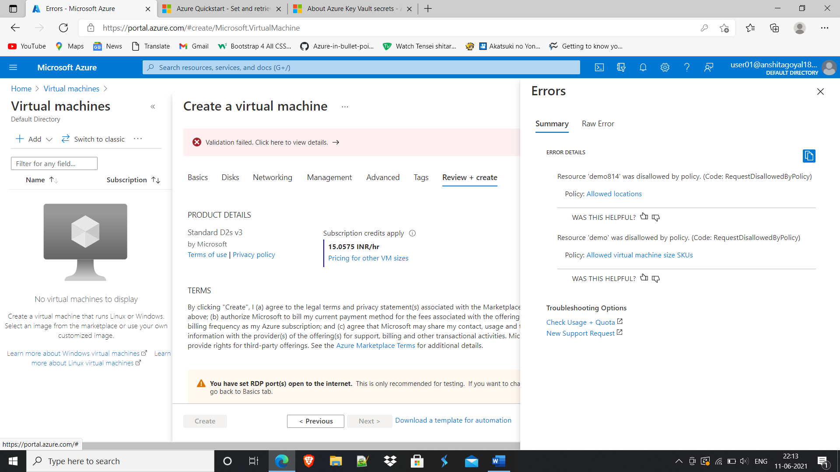

1. **Created two servers in Central US with size Standard_B1ms and kept both server in same availability set: set_us.**

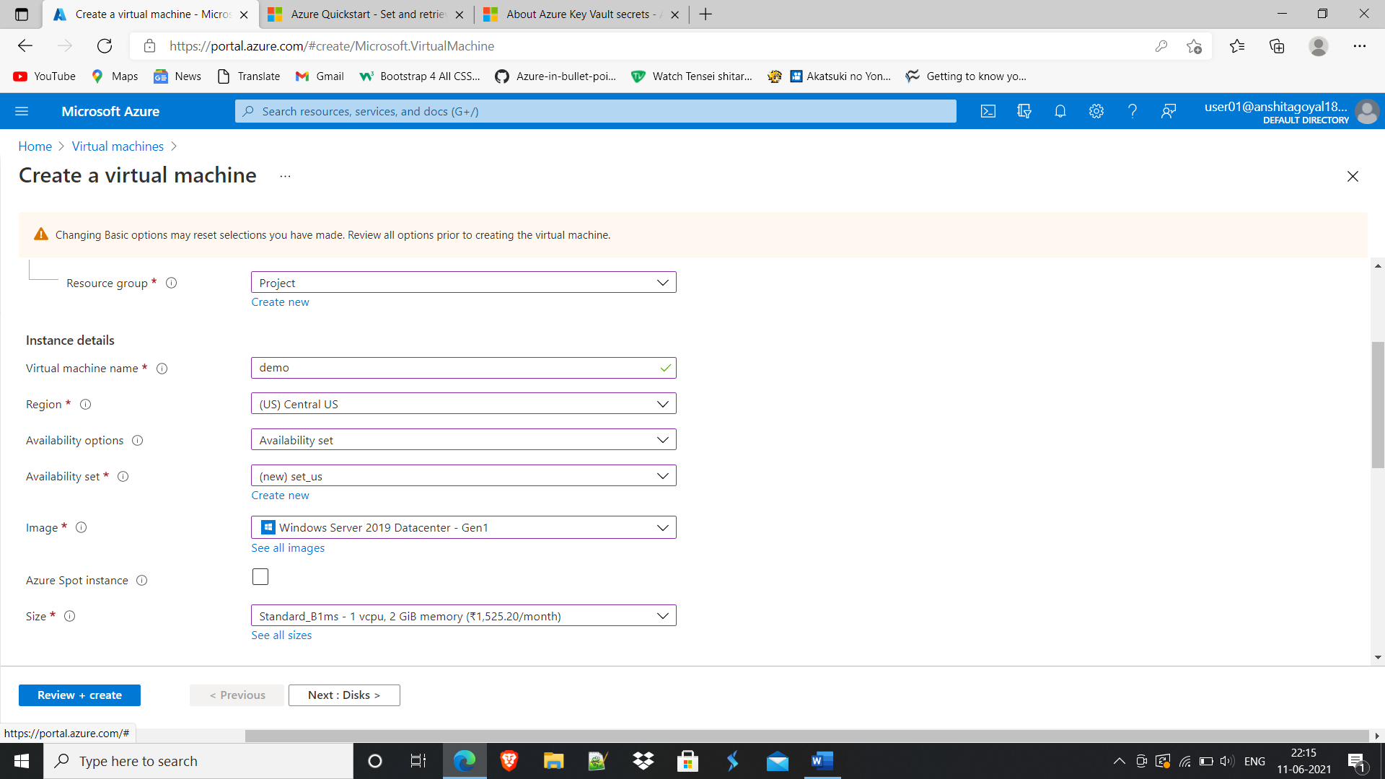

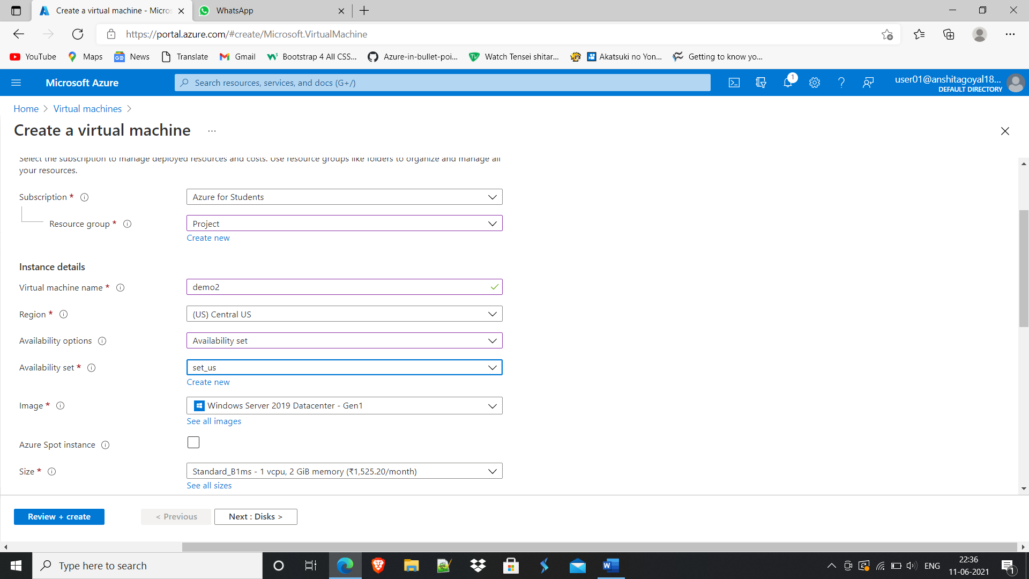

1. **Created Key Vault and stored server’s credentials in it.**

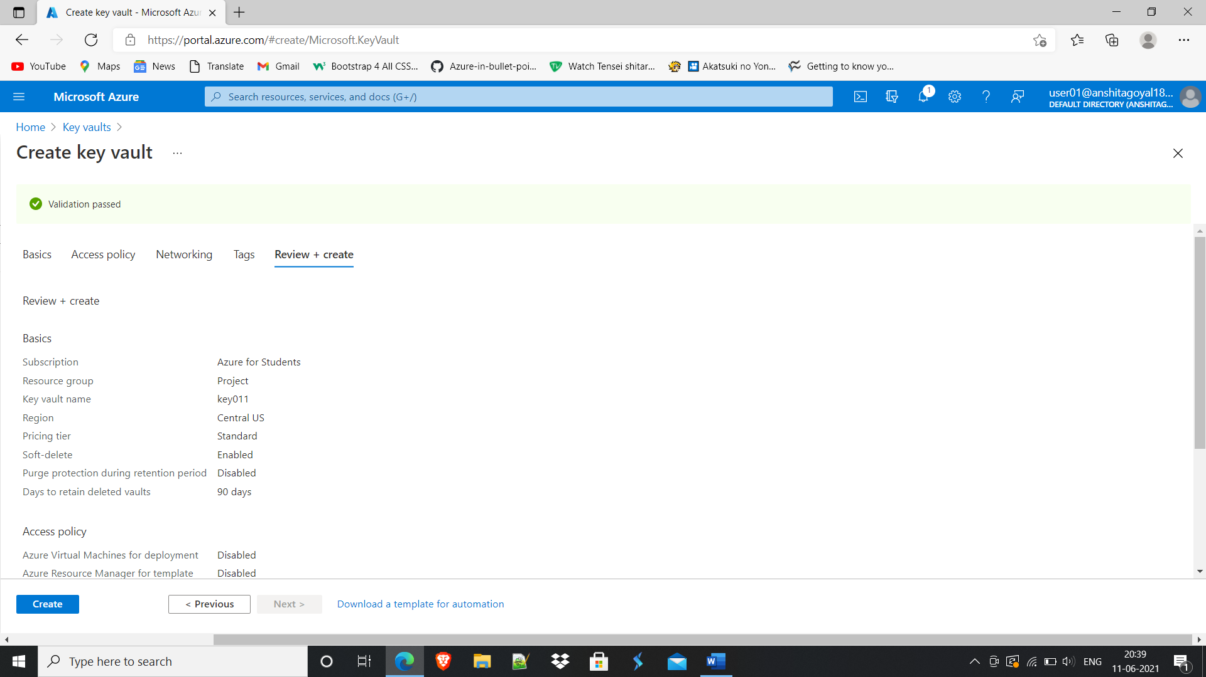

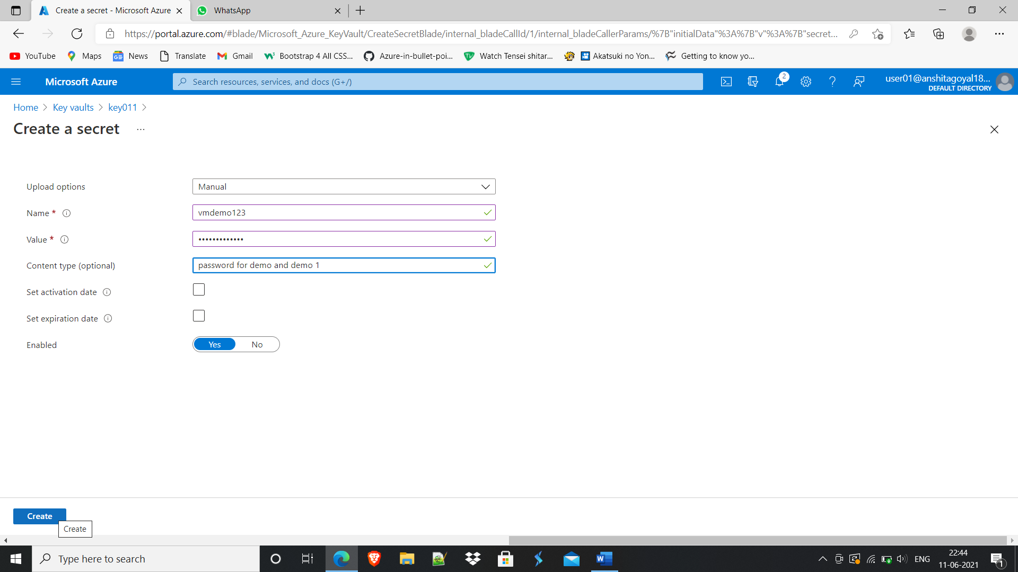

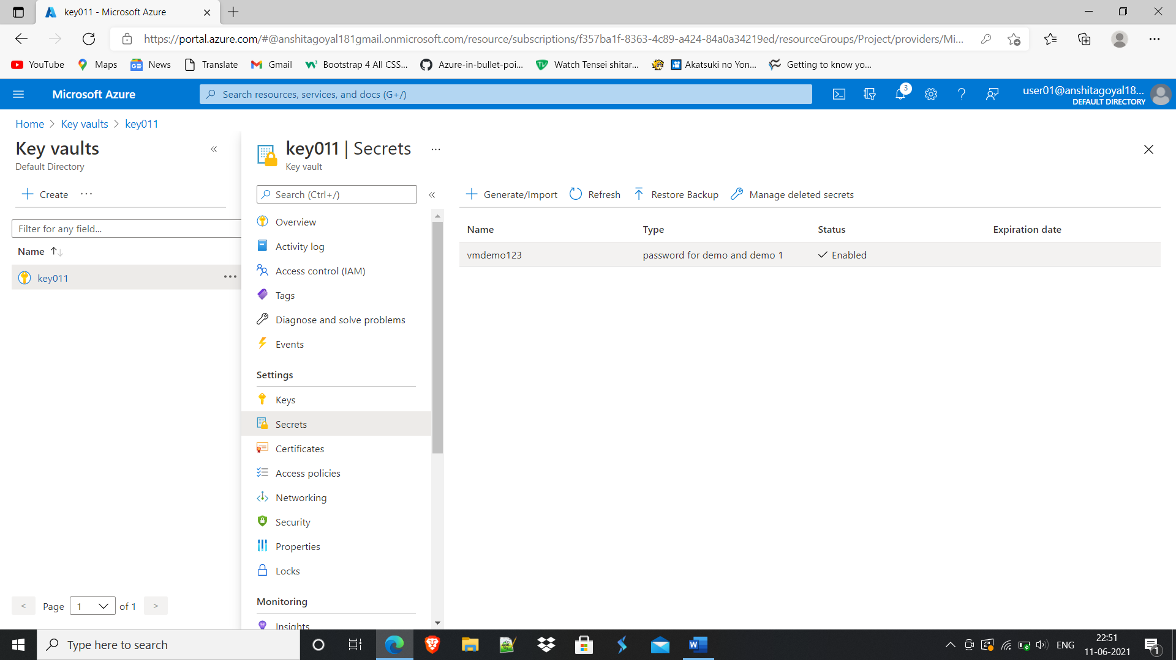

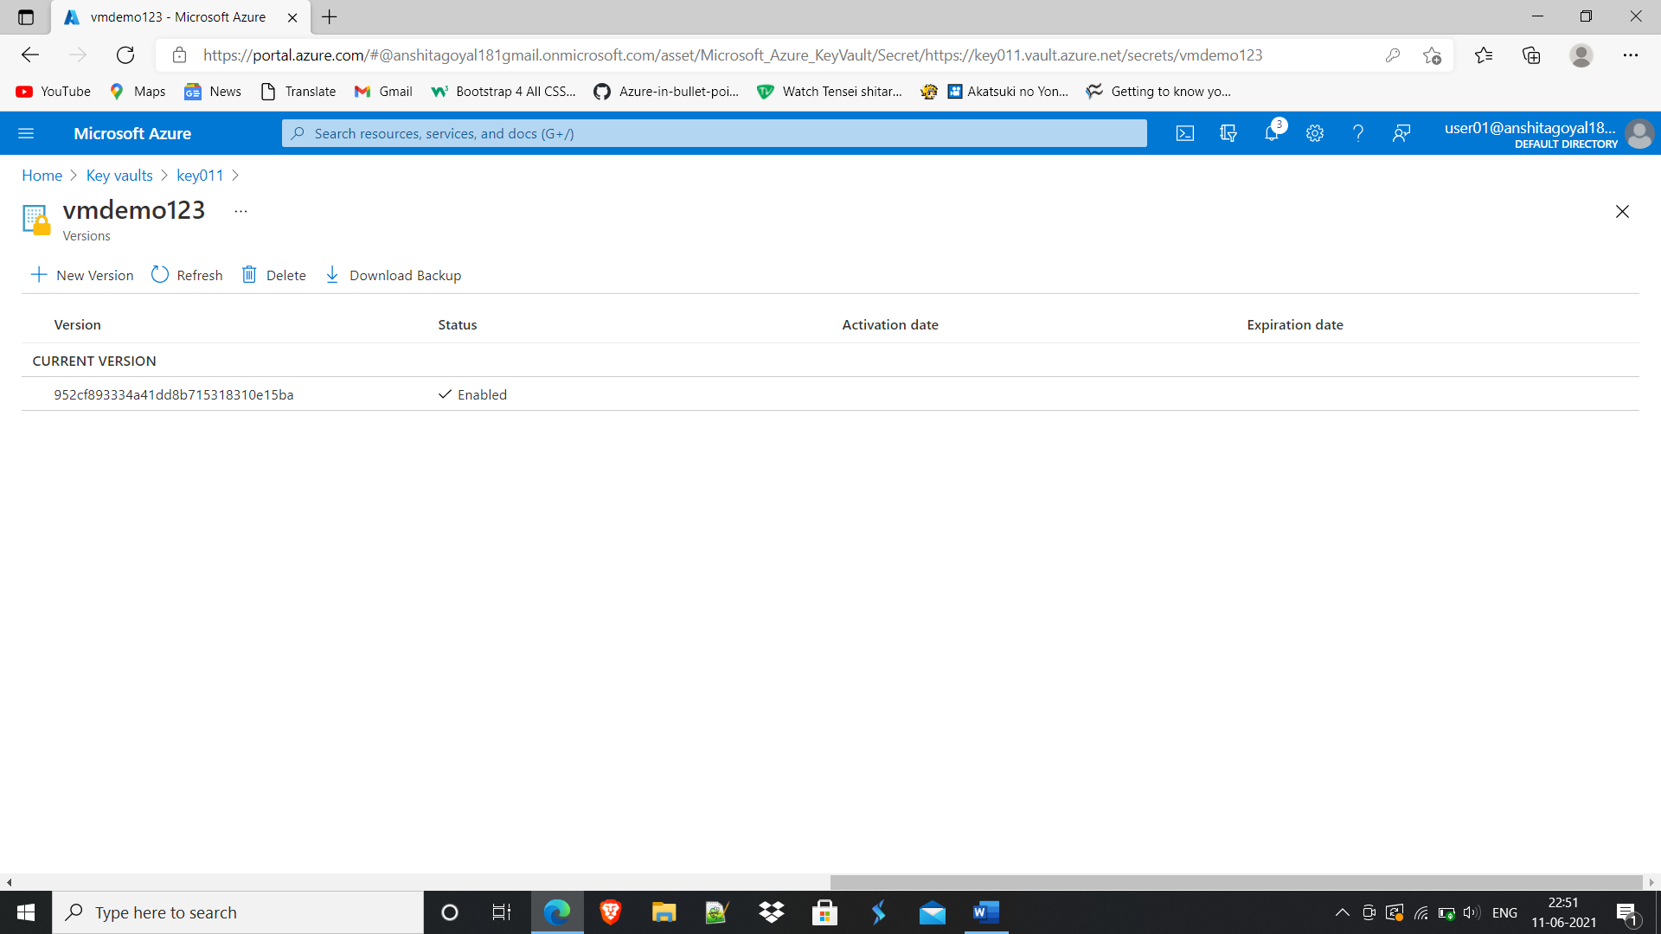

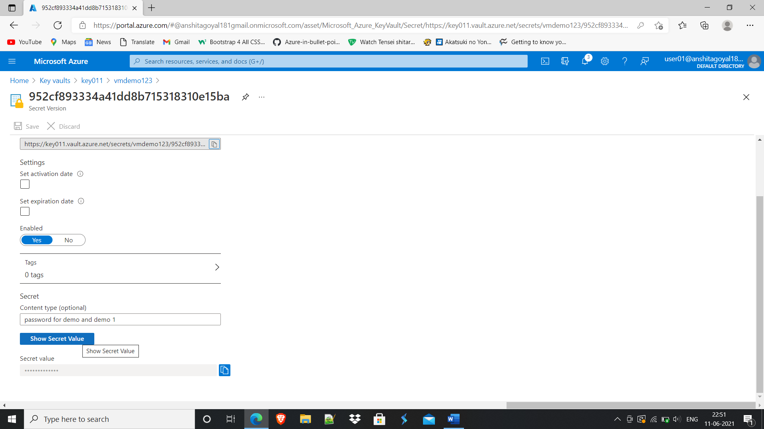

1. **Created and applied Locks at Resource Group level.**

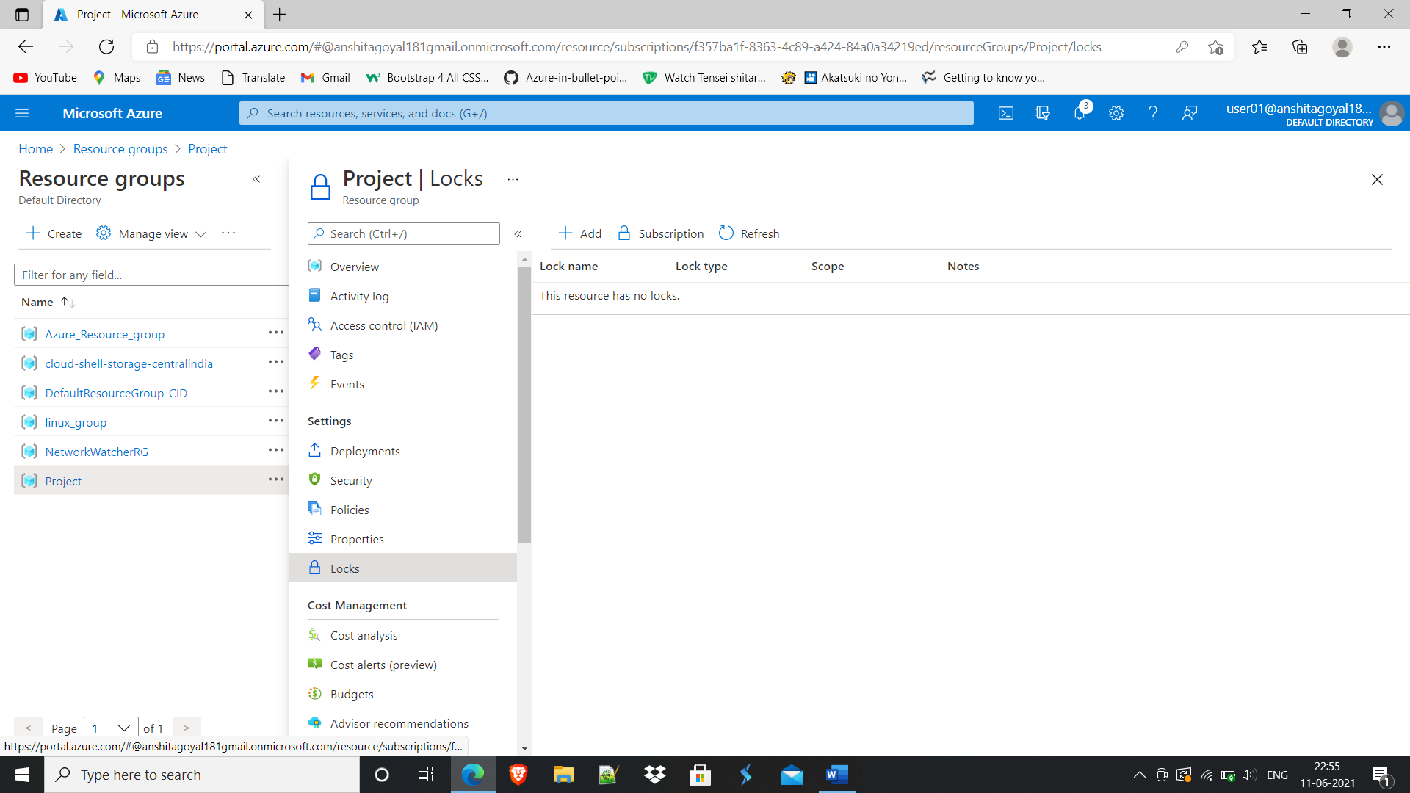

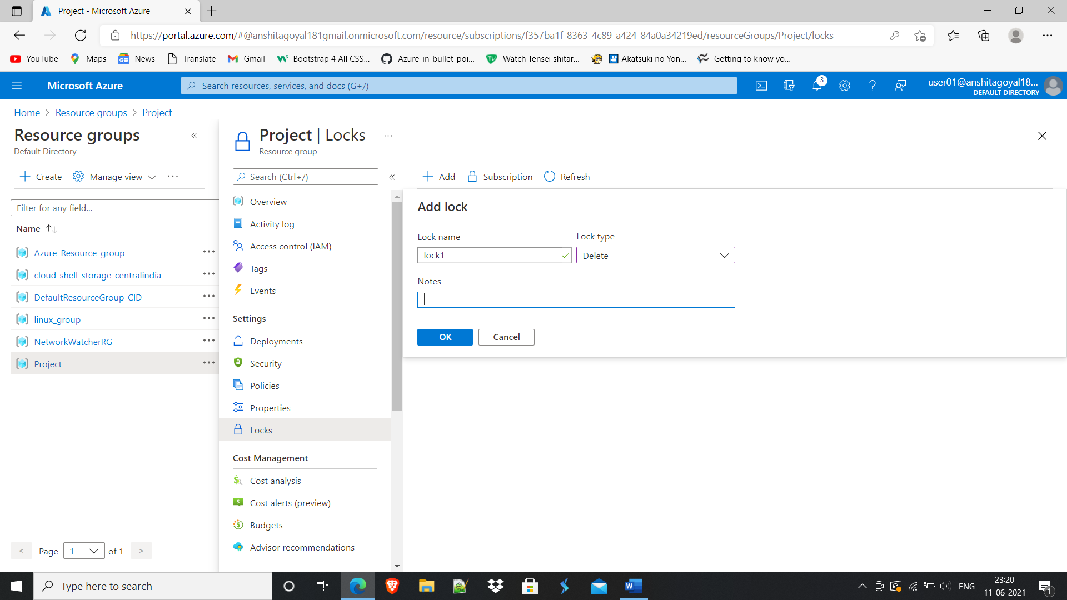

1. **Created Storage account.**

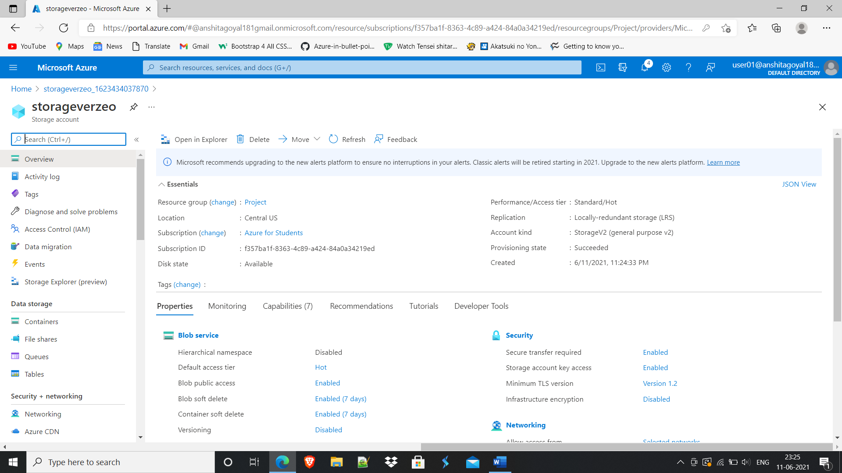

**Given access to respective client only.**

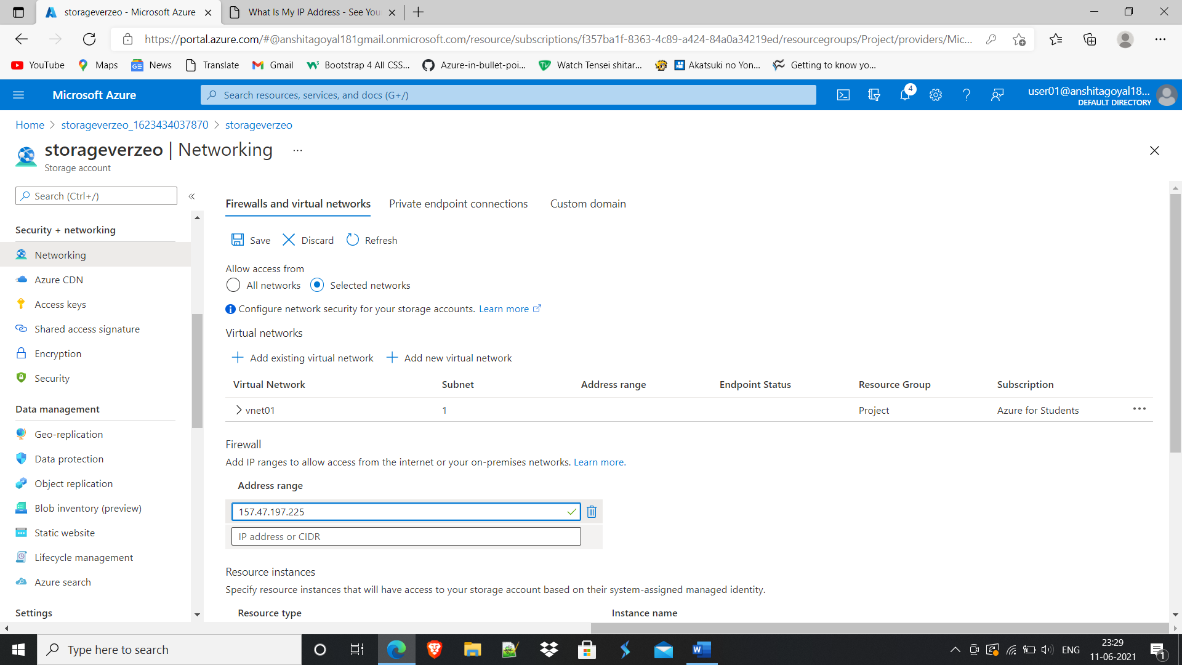

1. **Difference between Availability set and Availability zone.**

An **availability set** provides redundancy and availability for [virtual machines](https://cloudacademy.com/course/getting-started-with-azure-virtual-machines-988/course-introduction/). Deploying at least two virtual machines into an availability set ensures that at least one of them remains available whenever planned or unplanned maintenance occurs.

An availability set contains five update domains by default, although this can be increased to 20 update domains in resource manager deployments.

An **availability zone** is a unique physical location that exists within an Azure region. Every availability zone contains at least one data centre within the region. Each of these data centres has its own power, its own networking, and its own cooling. To ensure resiliency, every enabled region in Azure consists of at least three separate zones that are physically separated. It is this physical separation that protects applications from data centre failures.

Availability zones are similar in concept to availability sets. However, there is a distinct **difference**. **While availability sets are used to protect applications from hardware failures within an Azure data centre, availability zones, protect applications from complete Azure data centre failures.**